Exercise 2: Implementing the Factory Method Pattern
Design Patterns and Principles – Week 1

Scenario
A document management system needs to create different types of documents — Word, PDF, and Excel — without the client code being tightly coupled to the concrete classes of each document type. The Factory Method Pattern is used here so that the logic of deciding which document to create is delegated to subclasses of a factory, while the client only interacts with common interfaces.

Objective
- Define a common Document interface implemented by WordDocument, PdfDocument, and ExcelDocument.
- Create an abstract DocumentFactory class with a factory method createDocument().
- Create concrete factory classes (WordDocumentFactory, PdfDocumentFactory, ExcelDocumentFactory) that each override createDocument() to return their specific document type.
- Write a test class that creates each document type through its factory, proving the client never directly instantiates a concrete document class.

Approach
The Document interface declares the common behavior every document type must support: open() and save(). Each concrete class (WordDocument, PdfDocument, ExcelDocument) implements this interface with its own specific behavior.
The abstract DocumentFactory class declares the factory method createDocument(), which returns a Document but does not specify which concrete type. Each concrete factory (WordDocumentFactory, PdfDocumentFactory, ExcelDocumentFactory) overrides this method to instantiate the document type it is responsible for.
A shared method, getDocument(), is defined once in DocumentFactory. It calls createDocument() internally and opens the returned document, without knowing or caring which exact subclass was created. This is the core idea of the Factory Method Pattern — the parent class defines the workflow, and subclasses decide which object to plug into that workflow.

Class Design
- Document (interface) — declares open() and save(), implemented by all document types.
- WordDocument, PdfDocument, ExcelDocument — concrete classes implementing Document, each with its own open/save behavior.
- DocumentFactory (abstract class) — declares the factory method createDocument() and a shared getDocument() helper.
- WordDocumentFactory, PdfDocumentFactory, ExcelDocumentFactory — concrete factories, each overriding createDocument() to return their specific document type.
- FactoryMethodTest — demo/test class showing documents being created through their factories, including choosing a factory dynamically based on a string value.

Code: Document.java
package com.example.factory;

// common interface that every document type must follow
public interface Document {
void open();
void save();
}

WordDocument.java
package com.example.factory;

public class WordDocument implements Document {

@Override
public void open() {
System.out.println("Opening a Word document...");
}

@Override
public void save() {
System.out.println("Saving Word document as .docx");
}
}

PdfDocument.java
package com.example.factory;

public class PdfDocument implements Document {

@Override
public void open() {
System.out.println("Opening a PDF document...");
}

@Override
public void save() {
System.out.println("Saving PDF document as .pdf");
}
}

ExcelDocument.java
package com.example.factory;

public class ExcelDocument implements Document {

@Override
public void open() {
System.out.println("Opening an Excel document...");
}

@Override
public void save() {
System.out.println("Saving Excel document as .xlsx");
}
}

Code: DocumentFactory.java
package com.example.factory;

// abstract factory class - this is the heart of the Factory Method pattern
// each subclass decides which actual Document object to create
public abstract class DocumentFactory {

// the factory method - subclasses will override this
public abstract Document createDocument();

// this method is common for every factory, it uses createDocument()
// without knowing which exact document type it's dealing with
public Document getDocument() {
Document document = createDocument();
document.open();
return document;
}
}

WordDocumentFactory.java
package com.example.factory;

public class WordDocumentFactory extends DocumentFactory {

@Override
public Document createDocument() {
return new WordDocument();
}
}

PdfDocumentFactory.java
package com.example.factory;

public class PdfDocumentFactory extends DocumentFactory {

@Override
public Document createDocument() {
return new PdfDocument();
}
}

ExcelDocumentFactory.java
package com.example.factory;

public class ExcelDocumentFactory extends DocumentFactory {

@Override
public Document createDocument() {
return new ExcelDocument();
}
}

Code: FactoryMethodTest.java
package com.example.factory;

// test class to show how different document types are created
// using their respective factories, without the client code needing
// to know the concrete class being instantiated
public class FactoryMethodTest {

public static void main(String[] args) {

System.out.println("---- Creating a Word Document ----");
DocumentFactory wordFactory = new WordDocumentFactory();
Document wordDoc = wordFactory.getDocument();
wordDoc.save();

System.out.println("\n---- Creating a PDF Document ----");
DocumentFactory pdfFactory = new PdfDocumentFactory();
Document pdfDoc = pdfFactory.getDocument();
pdfDoc.save();

System.out.println("\n---- Creating an Excel Document ----");
DocumentFactory excelFactory = new ExcelDocumentFactory();
Document excelDoc = excelFactory.getDocument();
excelDoc.save();

System.out.println("\n---- Choosing factory dynamically ----");
// this shows the real benefit of the pattern - client code just
// depends on DocumentFactory / Document, not on concrete classes
String type = "pdf";
DocumentFactory factory = getFactoryByType(type);
Document doc = factory.getDocument();
doc.save();
}

// simple helper to pick the right factory based on a string
// (in a real app this could come from user input or config)
private static DocumentFactory getFactoryByType(String type) {
switch (type.toLowerCase()) {
case "word":
return new WordDocumentFactory();
case "pdf":
return new PdfDocumentFactory();
case "excel":
return new ExcelDocumentFactory();
default:
throw new IllegalArgumentException("Unknown document type: " + type);
}
}
}

Output
Running FactoryMethodTest.main() in IntelliJ produces the output below. Each factory creates and opens its own document type, and the client code (FactoryMethodTest) never writes 'new WordDocument()' or similar directly — it only calls factory.getDocument(), proving that document creation is fully delegated to the factory subclasses. The last block also shows a factory being chosen dynamically at runtime based on a string value. The program exits with code 0, confirming successful execution.
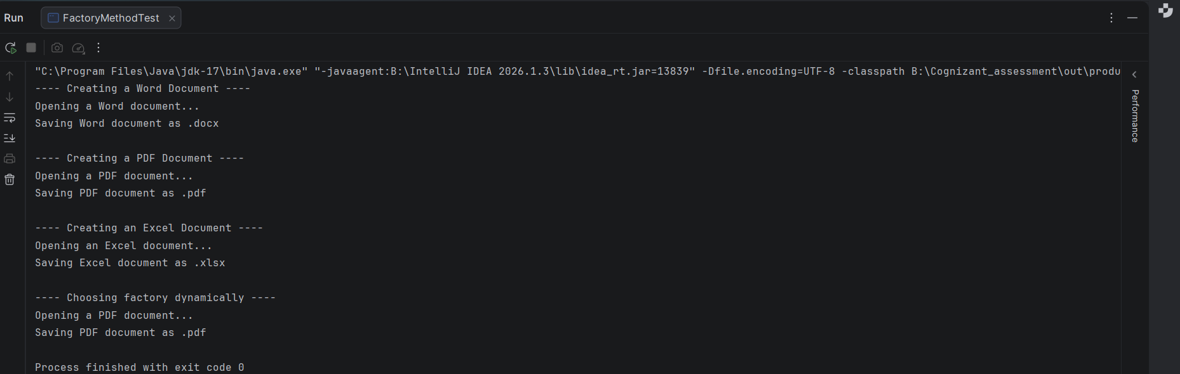

Conclusion
The document creation logic is successfully decoupled from the client code using the Factory Method Pattern. Adding a new document type in the future (for example, a PowerPointDocument) would only require creating a new Document implementation and a new factory subclass — no existing code needs to change. The output confirms that each factory correctly produces and opens its intended document type, and that the client can also select a factory dynamically without depending on any concrete document class.

